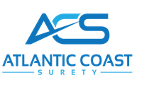
One International Blvd, Suite 405, Mahwah, NJ 07495 Ph: 201-252-3060 Fax 201-661-7363

Account Fact Sheet

Name

Address

Phone # Fax #

E-Mail

SCAC #

Tax ID #

FYE

Owner/
President

Address

SS#

Contact Person

Form Prepared by

Preparation Date

